**COVER PAGE**

Anmar Abdi, Ethan Mukwaya, Minchen Jiang, Lily Smokler, and Eli Porras (Team 1)

SI 250 Section D1

Professor Aboucalache

April 23, 2024

The “Home Rule”: Revitalizing the Boston Entertainment Scene Through Legislative Report Drafting

**Problem:**

A significant portion of the restaurants’ economic value stems from ownership of a liquor license, as alcohol sales—for restaurants that do possess alcohol licensing—contribute 20% of their economic output.1 However, obtaining a liquor license in Boston requires a hefty financial investment: managers must spend $400,000 and $150,000 for liquor and beer-and-wine licenses, respectively.2 As a result, established restaurants have monopolized the existing share, as “the wealthiest one-quarter of census tracts in Boston hold more than half of the available licenses.”3 Boston’s existing license distribution trend, in short, “favors larger restaurant groups over independent and perhaps more innovative restaurateurs.”4 This is significant because Boston liquor license ownership now concentrates on wealthier, more established restaurants, creating a disparity in revenue opportunities between Boston restaurants with licenses and Boston restaurants without.

The hefty price for obtaining a working liquor license, compounded by wealth inequities between rival restaurants and the monopoly of the wealthier companies as the majority of liquor license shareholders, strongly suggests that a gap exists: under-resourced restaurants in Boston don’t have the same opportunities as wealthier Boston restaurants to purchase a liquor license and generate significant customer and revenue yields towards their services. This gap needs to be addressed to allow all Boston restaurants, whether smaller startups or more established venues, a more equitable playing field to generate food service revenues and prevent heavy economic dependency on richer Boston regions with a greater number of food services.

Our focus in this project is to raise awareness of the disparities of Boston liquor licensing to push for legislative changes toward accessible liquor license access, allowing Bostonians aged twenty-one through forty years old to enjoy the entertainment scene to the fullest.

**Implementable Solution:**

To this end, our group created a comprehensive infographic report with statistics from Boston pedestrians regarding the magnitude of liquor licensing on attracting pedestrians, feedback from Boston restaurant managers across seven boroughs with recommendations to improve the city’s liquor licensing protocol, and an actively running petition and survey space embedded in our QR Code.

In times of economic inequality (like the current situation seen between wealthier Boston restaurants being able to purchase liquor licenses and introduce another income stream to their economic output and the less-wealthier Boston restaurants not having enough money to enjoy the same liberties), public opinion drives legislative agendas.5 Thus, the existing political literature supports our solution of raising public awareness toward Boston liquor license disparities and subsequently garnering public opinion. While our infographic report doesn’t directly amend the existing language in the city’s legislation toward liquor licenses, we take a pragmatic and important step forward in garnering a following from the Boston community, to later approach the city council and drive revisions in the existing policies.

**Design Process:**

**Data Gathering and Empathy Building:**

Our team conducted 80 in-person interviews — with Boston restaurant managers and pedestrians aged 21 to 40 — across six Boston boroughs (Newbury, Beacon Hill, Allston, Mattapan, Dorchester, and Roxbury) to understand the liquor license process and if liquor license ownership in restaurants affects restaurant economic growth and community members’ opportunities for entertainment enjoyment. Each group member interviewed five restaurant managers and ten pedestrians ages twenty-one and older, implementing a four-question survey for our interviews with Boston pedestrians aged 21 to 40 and a five-question open-ended interview format for our restaurant managers (Appendix: Interview Questions.)

Our interviewees’ onboarding process was intentional. We decided to interview restaurant managers because, as a 2024 study in Sweden suggests, restaurant managers own a part of the company’s liquor license and contain a considerable financial stake in the restaurant’s liquor revenue.6 Similarly, we decided to interview Boston restaurant pedestrians aged twenty-one through forty because, in a 2022 study conducted by the Massachusetts Alcohol Policy Coalition, only individuals twenty-one or older carried out alcohol orders, as twenty-one is the age requirement in the U.S. for alcohol purchasing.7 Furthermore, the Bostonian median age is 32.6 years old, suggesting that the twenty-one and older community largely drives the Boston economy.8 Thus, we implemented a screening in our interviewee onboarding process—asking the restaurant employees if we could interview only the manager and the pedestrians if they were twenty-one years or older—to yield insights from groups who can help us raise awareness.

Our twenty managerial interviews demonstrated that the Boston liquor license process reflects an ongoing monopoly that disproportionately benefits the wealthier, more established companies, hinders the smaller start-up businesses with fewer financial resources, and reveals a lack of a streamlined, online system where restaurants can apply, immediately schedule a restaurant inspection, and get a ballpark timeline of the process to approve their licensure. Thus, the managerial opinions demonstrated that recommendations exist to improve the Boston liquor licensing system. The sixty pedestrian interviews showed that offering drinks at local restaurants is the most important factor of restaurant customer service, with food coming at a close second and atmosphere as third (Figure 2.) Furthermore, all pedestrians noted they eat at restaurants at least once a week (Table 1.) These findings reinforce the notion that substantial revenue can be made from servicing liquor to restaurant customers, and that restaurant services are used regularly by the twenty-one to forty-year-old Bostonian target group.

In summary, our manager and pedestrian interviews suggest that manager recommendations exist to improve Boston’s liquor licensing system and citizens should be aware of the importance of these services which drive Boston's entertainment and economic growth.

**Refined Problem Statement and Specific Description of User:**

The current inequities in Boston’s liquor license approvals and distribution hit major local news outlets, such as WBUR, *The Boston Globe*, NBC Boston, and more; though, the rules were last amended as of 2005, even amidst the current liquor license news articles.9 Legislative change regarding Boston’s liquor licensing protocol has gone unchanged for years because government officials paused the revision plans to prioritize more pressing legislative agenda items.10 From our interviews with twenty-five Boston restaurant managers and fifty-five Boston pedestrians traveling to restaurants, the groups noted disparities in restaurants’ financial resources, the timeline for each business getting their liquor license application approved, the managers voicing their wishes for a streamlined, online liquor license application service that immediately schedules inspection dates and gives approximate timelines, and the importance of drinks driving Boston economic growth and customer attraction. To supplement our findings, the significant revenue yields despite the hefty financial investment in acquiring a liquor license stamps Boston liquor licenses as a vehicle for further economic growth.

The existing research and our primary research raise a new problem in dire need of solving: there needs to be a more streamlined process for existing Boston liquor license applications to increase the cap rate. Thus, we aim to revitalize the Boston entertainment scene by raising awareness with an infographic report and tailoring our solution toward raising public opinion from our users—Bostonians aged 21 through 40—who largely drive the economy and use liquor services in restaurants.

**Identification and Testing of Assumptions:**

We created our solution around two key assumptions. First, we assumed that Bostonian citizens aged 21 to 40 possess little to no knowledge of the logistics of liquor licensing approvals. Secondly, we assumed that Boston City Council members haven’t conversed one-on-one with restaurant managers when discussing recommendations to improve the liquor license conditions and approval process and with pedestrians to strengthen the restaurant experience. Considering the assumptions mentioned above, we synthesized an original infographic report with our pedestrian and managerial interview results to fully highlight the difficulties in the liquor license distribution processes and provide a platform for Bostonian citizens aged 21 to 40 to support our petition and voice their opinions.

**Solution Ideation:**

Our early rounds of solution ideation consisted of individual member brainstorming via the 6-3-5 method, with each member writing their idea down and continuing in a circle, which allowed us to either continue our solution in the same vein as the one previously mentioned or to chart a new path (Markman, 2017).11 We then engaged in constructive conversations about our prototypes, and after multiple deliberations, set a tangible and informative solution as the theme guiding our ideation. Since liquor licensing logistics revolve around the legislative sphere, we aimed for an educative solution presenting notable figures and managerial recommendations to garner the Bostonian public opinion of liquor licenses.

**Prototyping and Testing (Putting the Idea into Practice):**

Initially, our group debated on two prototypes: a public, educational workshop stand with hands-on activities raising awareness about the smaller startup restaurant stories and liquor licensing distribution plights in Boston (Appendix: Figure 5) and an educational, four-player board game simulation of the restaurant management process (Appendix: Figure 6.) However, our interviewee feedback on our prototyping caused us to pivot our solution medium. The manager at Lobstah on a Roll suggested a report or email about the liquor license process for community members to read about (Appendix: Interview Transcript 2), and the manager at Wagamama in Prudential Center recommended addressing the considerable backlog of businesses trying to obtain and even renew their licenses (Appendix: Interview Transcript 1.)

Thus, we changed our focus to now creating a comprehensive, data-driven infographic report with recommendations and active surveys for change because of our secondary research and the feedback from our interviewees—from both Boston restaurant managers and pedestrians. This added an extra dimension to the city council’s figures on liquor license statistics by providing qualitative analysis from managers and a survey of the restauranteurs' public opinion. Our final solution, the infographic report, contains the figures from our primary pedestrian interviews, recommendations from restaurant managers across six Boston boroughs on how to improve the city’s liquor licensing system, and a QR code with our community petition—featuring sections to fill out demographic information, any recommendations to improve the liquor licensing process and to support our ongoing petition.

**Next Steps:**

We would continue our prototyping and testing process by continuing to conduct in-person interviews with Boston restaurant managers and pedestrians 21-40 years old and outsourcing our infographic report to local Boston media outlets, such as WBUR, and The Boston Globe, and scheduling interviews with the news productions teams to see if we can further raise awareness to the local Bostonian 21-40-year-old community. After compiling findings from three thousand interviewees, we would then present our data findings and infographic to the city council for consideration in revising the liquor license caps and distribution regulations.

**Reflection:**

Each team member prioritized and upheld consistent communication throughout the entire iteration process by updating the other team members with interview status and numbers and detailed feedback and solution suggestions in our internal deliberations. Meeting our internal deadlines, as a result, flowed seamlessly. We ensured to hear and implement each group member’s insights and contributions to the highest possible capacity, especially in solution ideation, prototyping, and testing, to mold a product that represents an equal blend of our efforts. Per the class readings, creativity and breakthroughs increase as more individuals are introduced and as more recombinant ideas surface.12

Building in time to schedule and conduct interviews with restaurant managers initially proved challenging because each manager and each restaurant had a fluctuating schedule. When our members tried conducting interviews past five p.m., near dinner time, managers were too busy to interview, but during mid-afternoon times—two to five p.m.— managers did have the time to sit down. Thus, we worked through this challenge by catering our research times to the moments when restaurant managers were most free to be interviewed.

All in all, this project was extremely fruitful and rewarding, as we collaborated and came up with original ideas, conversed with the managers and enjoyers of Boston’s restaurant industry, and put all our learning into practice.

**Appendix:**

Synopsis: In this appendix, we provided the interview questions that our group members asked the managers and pedestrians, a pie chart showing the spread of our pedestrians’ answers, a word cloud highlighting the important takeaways from our interviews with local restaurant managers, a documented of a victualler liquor license from Wagamama at Prudential Center, and the iterations highlighting our prototyping process.

**Interview Questions:**

Restaurant Manager Interview Questions (Qualitative-Based):

1. Tell me more about your story, why did you choose to work/come here at this restaurant?
2. What is the process of obtaining a liquor license?
3. How important is it for restaurants to have a liquor license?
4. What resources can the city council invest in to provide for the community to better understand, support, and streamline the restaurant integration process, especially for minority-owned small businesses? What can students like us do?
5. How can the city improve the liquor license process?

Pedestrian Questions (Quantitative-Based):

1. How affordable is entertainment here? (1-5, 1 = not affordable, 5 = very affordable)
2. Most important factor in customer service experience? (drinks, food, entertainment, atmosphere, location)
3. How often do you go out a week? (0-2, 0.5 = once a week, 2 = almost every day per week)
4. How much do you think restaurants/event spaces drive economic growth in your community? (1-5, 1 = not a big factor, 5 = crucial factor)

Table 1: Data analysis of pedestrian interview responses (n = 60).

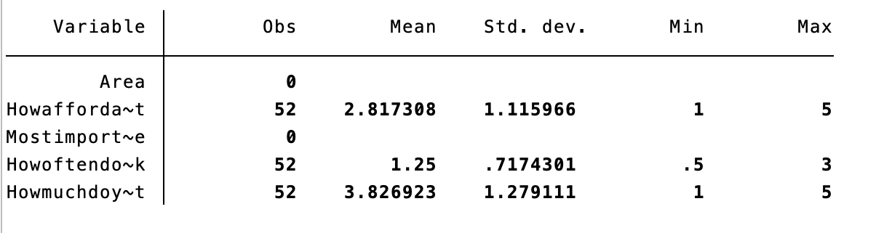

Table 2: Pedestrian input (n = 60) of entertainment affordability in six Boston boroughs (Allston, Beacon Hill, Dorchester, Mattapan, Newbury, and Roxbury) on a scale of one (not very affordable) to five (extremely affordable.)

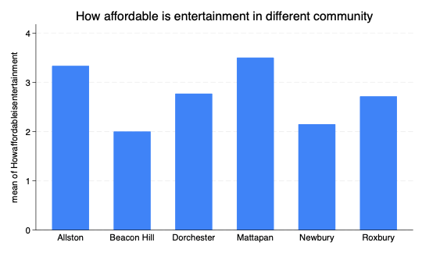

Table 3: Pedestrian responses (n = 60) of how restaurants drive economic growth on a scale of one (not very much) to five (extremely paramount and important to economic growth.)

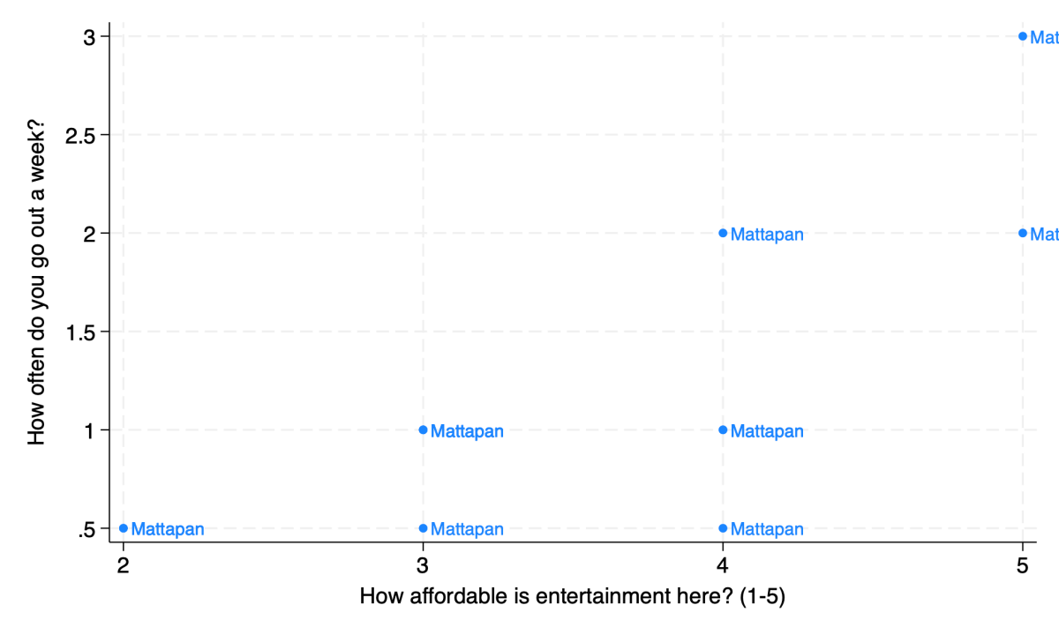

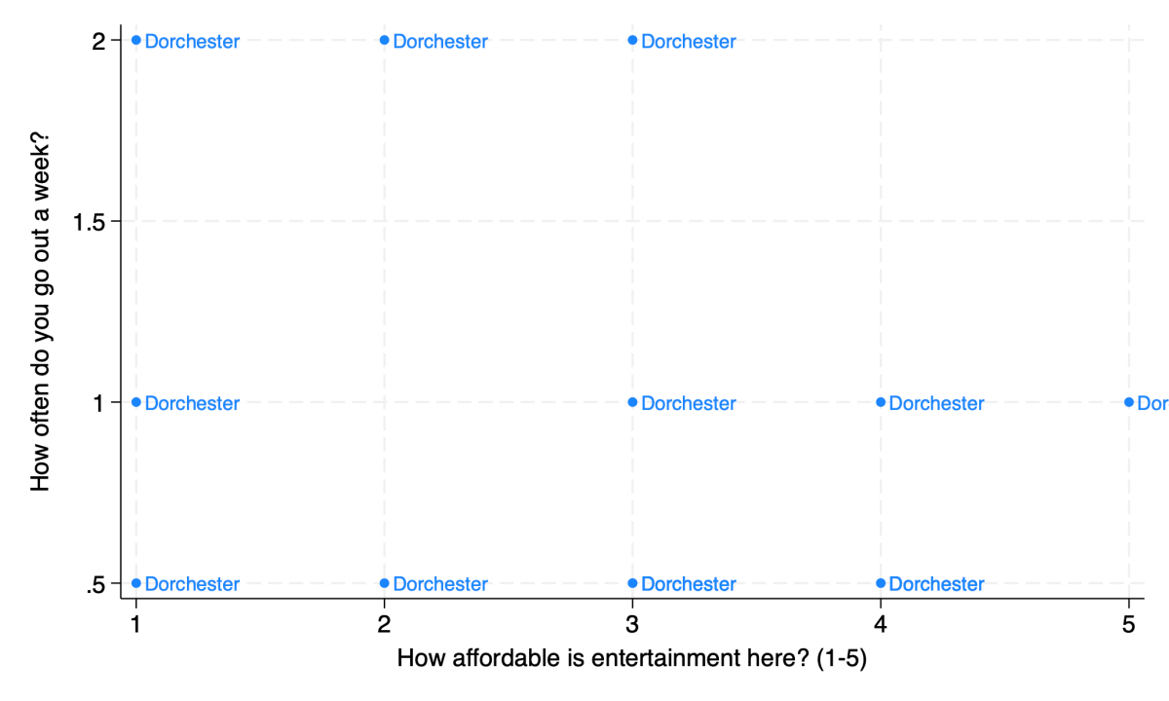

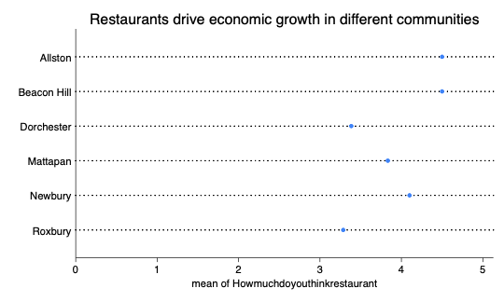

Interview Transcript 1: Daniel Emeka Muforo, Manager of Wagamama at the Prudential Center in Boston, MA.

Members Eli Porras and Minchen (Jason) Jiang of Team One interviewed Daniel Emeka Muforo, the manager of Wagamama at Boston’s Prudential Center, on Saturday, April 13 at 4:30 pm. The members asked group questions regarding logistics in the liquor license process and areas to improve the equity and speed of Boston’s liquor licensing approvals.

[Eli]: What motivated you to work here, and why this restauraunt?

[Daniel]: That’s a good question. I’ve been in the restaurant business since 1998. I used to own a company called Jerk Chicken Express, and my restaurant is five units out of Florida. Yeah, so I joined Wagamama because of the love I have for the company. We used to call it Asian Fusion, but that’s now not a politically correct word to use, so this is more like an Asian cuisine. So, I love the company, and it’s like a family. That’s what motivated me: the love that I have for the company in general. So what school do you guys go to?

[Eli and Jason]: Boston University.

[Daniel]: Boston University, is that right? What are you studying?

[Eli]: I’m a sophomore, I study biology.

[Jason]: I study economics.

[Daniel]: I see. I gave a speech about two months ago for an entrepreneurship class. You don’t happen to be taking entrepreneurship, do you?

[Jason]: We do, and this project is for that class.

[Daniel]: Do you know Professor Estavan?

[Eli and Jason]: No.

[Daniel]: Yeah, it was that class that I gave my presentation to.

[Eli]: We are in Professor Abouchalache’s class.

[Daniel]: Oh wow! Yes, I have heard of him too. That’s interesting! So entrepreneurship?

[Eli]: Yes.

[Daniel]: Nice! Yes, I was there two to three months ago, I pretty much told them how I opened up a jerk chicken restaurant, and the process, and all that, from beginning to end. Good. What other questions do you have for me?

[Eli]: Sounds great! Yes, so getting straight into it, could you walk us through the process of obtaining a liquor license?

[Daniel]: So the liquor license, yes, I think the main thing is money. The major thing that you need is the funding because, depending on what license you are getting, one is the cordial license, which doesn’t allow you to sell every alcohol because you only have the basic [...] But when you go into the vodka, you know, when you try to sell beer-and-wine and the entire, that’s when you get the victualler license. But you know, the first thing: you submit your application. And of course, the city of Boston will bring in lawyers, the city will look into your business to see if you are up to par. What I mean by that is that you can protect the investment, because the liquor license is very hard to get but very easy to lose. And I’m sure you guys probably know, there are a lot of beverage laws where we’re not allowed to sell to minors. You have to be twenty-one to drink, so yes. The city will pretty much see if you are up to par if you can protect that license, and if you get into all of the details, of course, with your money because we invest $250,000. So that’s a lot of money. And we only have the [cordial?] license, so yes.

The first thing is to submit the application, pay the fees, and then follow the protocol. The final thing will be the hearing, where you designate a business member, what business manager who the license will be named under. And once you get your approval…the process takes 90 days to a whole year, depending on the business: your location, if you pass the inspection, easy. If you don’t pass the inspection, you have to pretty much start over again.

[Jason]: I also heard that in the community, if you want to get a liquor license, other managers of the restaurant will have to vote for whether you can get the license.

[Daniel]: Yes, so sometimes, you get a reference. Let’s say if you own this restaurant now, you could have maybe business partners, or other restaurant owners, others that know you, to endorse you. Or vote for you. In my case, I used the reference because I used to run the [Kingsbowl?] in [town?]. And my name was on the liquor license already, so the city of Boston already had me on their list. So, when I transferred over, it was easy for me to get a reference.

But yes. When they have the hearing, every lawyer and other business involved, the city has to actually bring up your business, and they look into your record. Your record will determine whether they will say yes or no; in other words, vote yes or no for your license. If you have some violations in the past, that could trigger someone to say, well, what’s your name?

[Jason]: Jason.

[Daniel]: Jason LLC, we can’t give you your license, because of ABC, which was maybe some violations in the past or maybe your record. Let’s say, for instance, if you sold a minor, or someone who wasn’t the age of twenty-one, or any record at all, the city will look into that. If you have a clean record, the better. If not, when you talk about the voting yes or no, that’s what can trigger someone to say, “Well, we can’t give you your license because you won’t be able to protect it.” If the majority says yes, then you’d be good to go.

Another thing they check is not just your business record, but your record as well. They’ll check your home address, to make sure you’re a resident of the city, or the locality of where you do your business. In other words, you can live in Florida, and hold a Boston, MA liquor license. Your business has to be here to be able to get the approval. What else?

[Eli]: From your perspective, how important it is for restaurants to have a liquor license? Is that really important?

[Daniel]: When you talk about profit, there’s big money to be made selling alcohol. And I’ll give an example. We’d buy a bottle of wine for ten bucks. You sell that, after, you make three hundred bucks. So, the answer is yes. There’s big money selling alcohol. So it’s a big thing to have the license. But, it’s not easy though. It’s not an easy thing. So yes. What else?

[Eli]: What resources can the city, or even students like us, to try and invest in so we can raise awareness about the liquor licensing process?

[Daniel]: I think everything boils down to credit. Even if you are looking to open you’re own business, at the end of the day, you need good credit. So, credit would determine what banks will invest in your business. And when I say credit, not just FICO scores, but also your record, your background as well, because your background check comes in before the issued license. For instance, if I have a criminal record, the city of Boston wouldn’t give me a license. Let me show you guys an example of what I am talking about.

At this moment, Daniel, Jason, and Eli walk to the alley of the restaurant where the laminated victualler liquor license rests on the wall facing the washrooms. Daniel shows us Wagamama’s liquor license and explains the conditions that come with the license, the requirements for showing the license in the store (should a city inspector come around,) the renewal process, and the signatures from city council members. After the brief intermission, Jason took a picture of the laminated license, and the three return to the table to conclude the interview.

[Eli]: How can the city fix the liquor licensing process?

[Daniel]: The city, especially the city of Boston, has a very bureaucratic system. And when I say that, when you apply for a license, there’s always a backlog. You know, they might not be able to get back to you for two months. So what I suggest they [the city] will do is to have a system in place where, once you submit your application, you get a feedback writing or a response email saying “We have your application,” a timeline that will tell you immediately, it will take us a month, two months, three months, or whatever the case may be, and then keep you up to date. Because there have been times where I have to call and call and call to remind them that I am trying to renew my license, can somebody help me out here?

So, to me, I think they [the city] should do better. What does that mean? Hiring more employees at the city hall or streamlining a system to have everything online, where you can apply, pay, and get your inspection scheduled immediately so you don’t have to worry about calling humans. So yes, I think the bureaucracy can be the major hiccup.

[Eli]: Great answer. It looks like that’s all we have, thank you for taking the time today to interview with us. Your responses have been extremely helpful.

[Daniel]: No problem, and you two take care and best of luck with your project.

Interview Transcript 2: With Danielle Dearmon-Brown, Manager of Lobstah on a Roll at Newbury Street in Boston, MA.

Members Eli Porras and Minchen (Jason) Jiang of Team One interviewed Daniel Emeka Muforo, the owner of Wagamama at Boston’s Prudential Center, on Saturday, April 13 at 4:30 pm. The members asked group questions regarding logistics in the liquor license process and areas to improve the equity and speed of Boston’s restaurant community.

[Jason]: Tell us your story, why did you decide to work at this restaurant?

[Danielle]: I was really drawn to the company’s mission of giving people welcoming service and catering to Boston and Latin American Cuisine.

[Jason]: What is the process of getting a liquor license?

[Danielle]: It is not so easy, and there are lots of requirements. This restauraunt doesn’t have the full liquor license where we can sell all types of liquor, but we do have a beer-and-wine license which costs $250,000. On Newbury Street, only 30% of restaurants have liquor licenses.

[Jason]: What advice do you have for newer startup restaurants trying to establish a foothold in the local Boston restaurant community? Any recommendations for specific resources or connections?

[Danielle]: Definitely helps to having street patios for the restauraunts. Newbury is closing for the summer so pedestrians won’t have access to the streets, though it is hard to put resources since money is needed for parking lots and because Newbury Street is closed, it would be hard to put money into the street patios which help attract customers.

[Jason]: What resources can the city invest in to provide for the community to better understand, support, and streamline the restaurant integration process, especially for small businesses? What can students like us do?

[Danielle]: I think submitting an email or a report for us community members to read about the liquor licensing process will help, having something to read about that gives us the big numbers and areas to look out for. Send us an email within the week, and we will be sure to read it and give you feedback.

[Jason and Eli]: Sounds good. Thank you for your time.

Figure 1: Interview word cloud representing the main takeaways from pedestrians and restaurant managers alike, identifying areas of change in facilitating stronger economic output from restaurants and solution ideas to raising awareness on Boston liquor license distribution woes, all in one-to-four word blurbs (n = 80.)

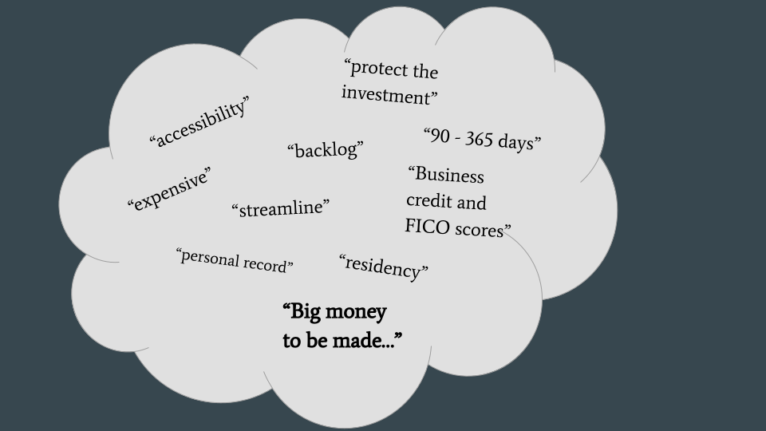

Figure 2: Quantitative impacts of restaurants and liquor licenses in the city, and the driving factor for restaurant success from the pedestrians’ points of view (n = 60)

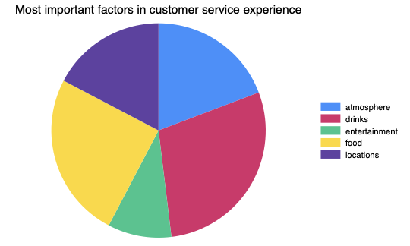

Figure 3: Original copy of an approved, limited liquor license of Wagamama, an Asian fusion restaurant in the heart of Prudential Center in Boston, MA. Includes the city council members’ official signatures and approval, the conditions upon displaying and using the liberties offered in the licensure, and the expiration date.

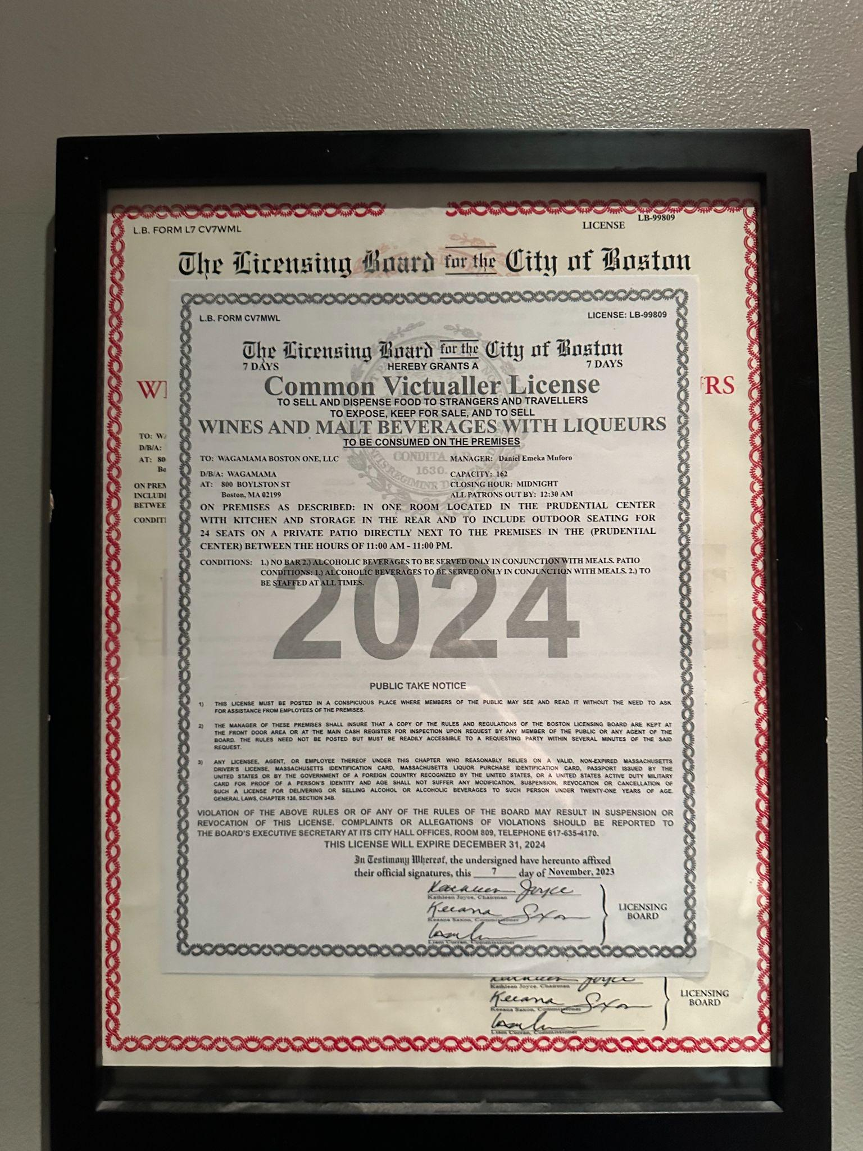

Figure 4: An original infographic highlighting the areas of Boston liquor licensing garnered from the eighty interviews, including the most important factor in restaurant customer service, the perceived impact of Boston restaurants on economic growth, costs of liquor and beer-and-wine licenses, entertainment affordability in six Boston locations, and Boston liquor license distribution among its city sectors.13

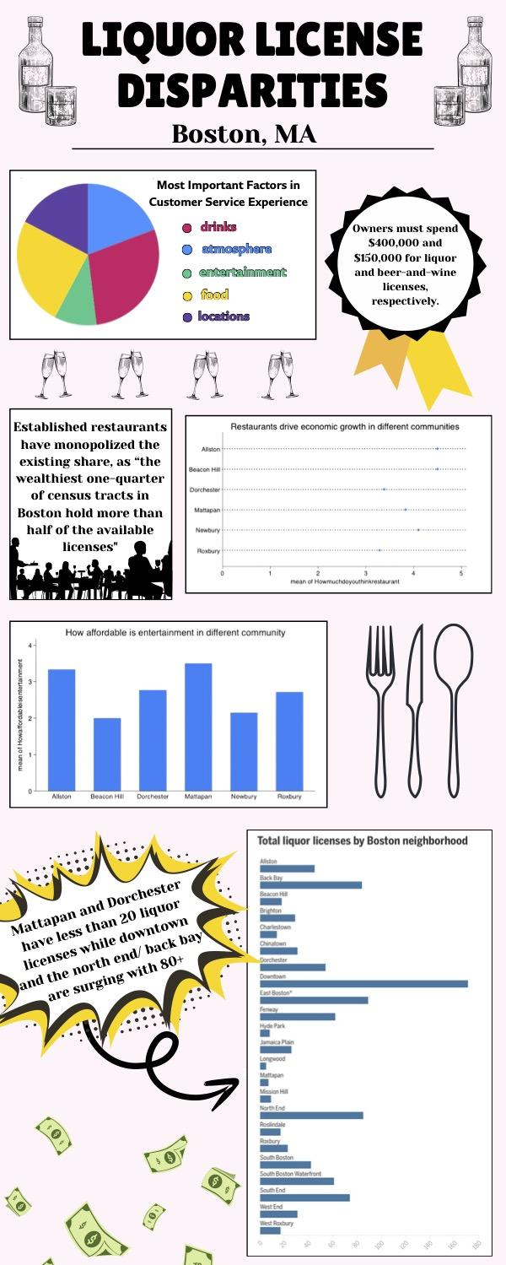

Figure 5: A hand-made sketch brainstorming our visualized workshop (Prototype One.)

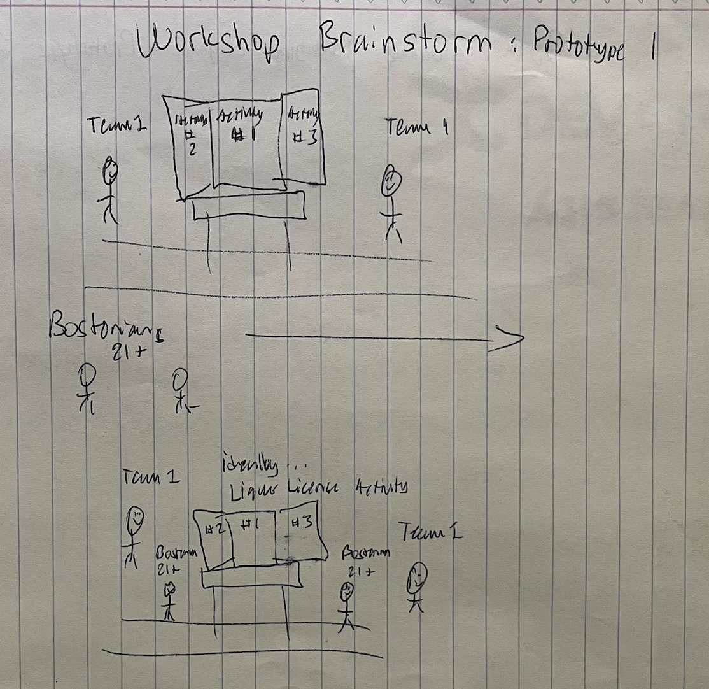

Figure 6: A hand-made sketch of the layout of our educational board game (Prototype Two.)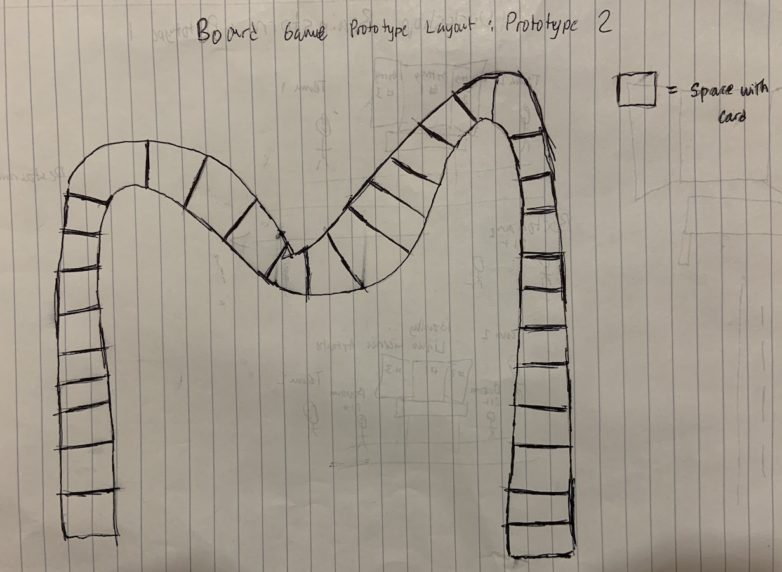

Figure 7: Initial infographic with Team One’s primary and secondary research on liquor license disparities (Prototype Three.)



Figure 8: Final infographic including Team 1’s primary and secondary research on Boston’s liquor license disparities, an original QR code for data collection and supporting a petition to push for legislation changes on Boston’s liquor licensing policies, and a revitalized service title (Final Solution.)

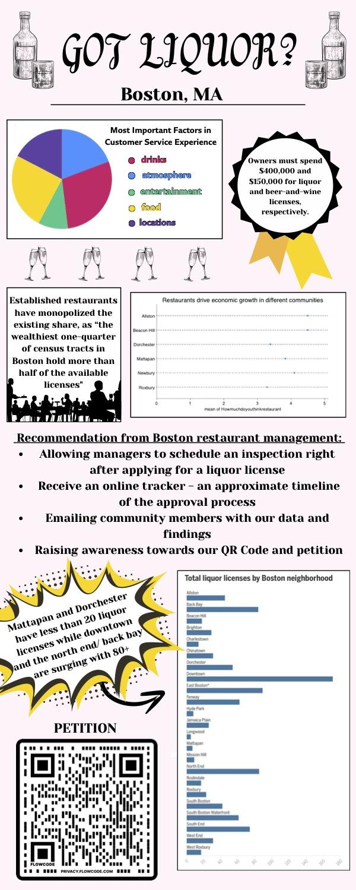

# Endnotes

1. Drago, Lauren Shuffleton. *Liquor License Distribution in Boston: Exacerbating Economic Disenfranchisement*. Diss. Tufts University, 2017. <https://sites.tufts.edu/gis/files/2017/06/Shuffleton_Lauren_GIS102_2016.pdf>.

2. Ibid.

3. Edwards, Chris. "The Small Business Administration and Policies for Entrepreneurship." (2022).

4. Edwards, C. Entrepreneurs and Regulations. (2021).

5. Epp, D. A., & Borghetto, E. (2021). Legislative agendas during periods of inequality: evidence from Europe and the United States. *Journal of European Public Policy*, *28*(4), 536.

6. Bååth, J., & Nilsson, J. (2024). The art of being governed: the implementation of Covid-19 policies in Swedish on-license alcohol service. *Food, Culture & Society*, *27*(1), 202-220.

7. Jernigan, D. H., & BID, X. Z. Alcohol, Health and Safety In Massachusetts.

8. “Boston, MA.” DataUSA, 2023. <https://datausa.io/profile/geo/boston-ma>.

9. Wu, M. M. (n.d.). *General Rules - Licensing Board for the City of Boston*. City of Boston. <https://www.boston.gov/sites/default/files/file/2021/11/rules_and_regs_amended.pdf>.

10. Lisinski, Chris. (2024). “Gov announced, but didn’t file, liquor license reform.” NBC Boston. <https://www.nbcboston.com/news/local/gov-announced-but-didnt-file-liquor-license-reform/3255798/>.

11. Markman, Art. “Your Team is Brainstorming All Wrong.” Harvard Business Review, 2017. <https://hbr.org/2017/05/your-team-is-brainstorming-all-wrong>.

12. Fleming, Lee. “Breakthroughs and the ‘Long Tail’ of Innovation. MIT Sloan Management Review, 2017. <https://sloanreview.mit.edu/article/breakthroughs-and-the-long-tail-of-innovation/>.

13. McDonald, Danny. “The whiter the Boston neighborhood, the easier it can be to find a restaurant to serve booze, report shows.” The Boston Globe, 2022. <https://www.bostonglobe.com/2022/06/20/metro/only-2-percent-boston-liquor-license-holders-are-black-new-report-reveals-startling-disparities/>.